Possible Question List For PSC Viva
- ICT Policy (Thottho projukti nitimala 2009), Its vision (Rupkalpa)
http://www.bcc.net.bd/Policy/ICT-Policy-2009-Bangla-Revision-23-01-2011.pdf
Here are some parts to study:


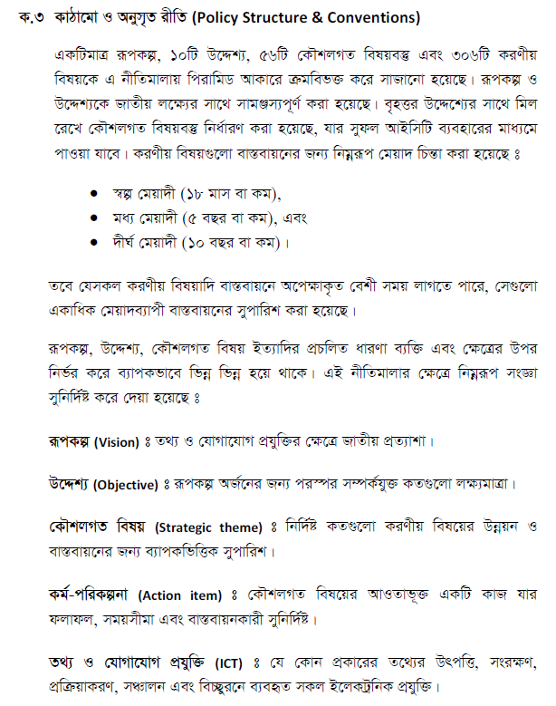

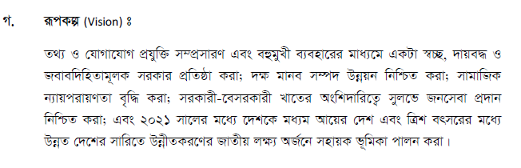
Recent Updates About ICT Policy:
The cabinet today approved the draft of the 'National Information and Communication Technology (ICT) Policy-2015' aimed at development and promotion of ICT sector to ensure its effective use to achieve nation's development goals.
The approval was given in the weekly meeting of the cabinet held at Bangladesh Secretariat with Prime Minister Sheikh Hasina in the chair.
Briefing reporters after the meeting Cabinet Secretary M Musharraf Hossain Bhuiyan said the policy is an updated version of the ICT Policy-2009 which has been revised with the opinions of all stakeholders, ministries, experts and professionals.
"The ICT policy will be less regulatory but more developmental and promotional," he said, adding that the policy will be a guideline for the sector to ensure comprehensive and effective use of ICT to materialize the government's vision to make Bangladesh a middle income country by 2021 and a developed one by 2041.
The cabinet secretary said the main vision of the policy is to promotion and multipurpose use of ICT to ensure transparency and accountability of the government, human resources development, ensure public services through public and private sector participation and achieve national development goals by 2021 and 2041.
The policy has ten special objectives, 56 strategic themes and 306 action programmes which will be implemented by different organizations under short, medium and long term timeframe by 2016, 2018 and 2021.
Cabinet members, advisors, state ministers in charge of different ministries and concerned secretaries attended the meeting.
The cabinet was informed about the official visit of the Information Minister to Malaysia from August 17 to 24, 2014. The meeting was also informed about the visit of the Information Minister to Tehran from December 1 to 4 last year to attend 10th Session of Islamic Conference of Information Ministers (ICIM).

- Explain yourself in English (About your educational life)
Explanation means you name, Birth year & district, Sequentially SSC, HSC, BSC, MSC Information (Say Passing year, Class/Division, Percentage, Institution very LOUD and Clearly). Bcoz they will put marks according to your result. So they need to know it clearly.

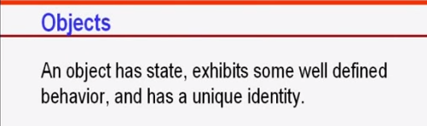

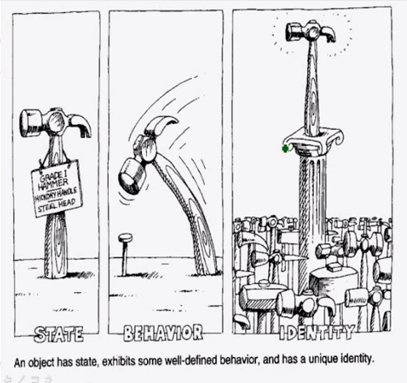
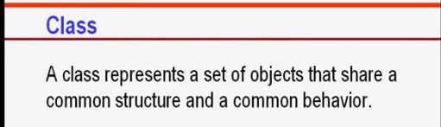

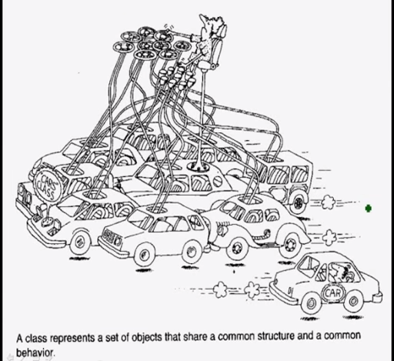

Recipients of the Bir Srestho[edit]
All the recipients of this award were killed in action during the Liberation War of 1971. The award was published by the Bangladesh Gazette on 15 December 1973. It is the highest military award of Bangladesh, similar to the American Medal of Honor or the British Victoria Cross. It has only been given in 1973 to seven people. Listed below are the people who have received the Bir Srestho. They are all considered 'Shaheed' (Martyrs).

§Bangladesh Army[edit]
Serial No. | ID Number & Rank | Name
1 | BSS-10439 Captain | Mohiuddin Jahangir
2 | 3943014 Sepahi | Hamidur Rahman
3 | 3937798 Sepahi | Mostafa Kamal

§Bangladesh Navy[edit]
Serial No. | ID Number & Rank | Name
4 | 62066 Engine Room Artificer, Class-1 | Mohammad Ruhul Amin

§Bangladesh Air Force[edit]
Serial No. | ID Number & Rank | Name
5 | Pak/4367 Flight Lieutenant | Matiur Rahman

§Bangladesh Rifles Currently known as Border Guard of Bangladesh[edit]
Serial No. | ID Number & Rank | Name
6 | Lance Naik | Munshi Abdur Rouf
7 | 9459 Lance Naik | Lance Naik Nur Mohammad Sheikh

List of Sectors and Subsectors[edit]
Sectors^{[1]} of Bangladesh Liberation War
Sector | Area | Sector Commander | Sub Sectors (Commanders)
1 | Chittagong District, Chittagong Hill Tracts, and the entire eastern area of the Noakhali District on the banks of the riverMuhuri. The headquarters of the sector was at Harina. | • Major Ziaur Rahman (April 10, 1971 – May 15, 1971)  • Captain Rafiqul Islam (June 10, 1971 – February 14, 1972) | - Rishimukh (Captain Shamsul Islam);  - Sreenagar (Captain Matiur Rahman, Captain Mahfuzur Rahman);  - Manughat (Captain Mahfuzur Rahman);  - Tabalchhari (Sergeant Ali Hossain); and  - Dimagiri (Army Sergeant, name unknown to date).
2 | Districts of Dhaka, Comilla, andFaridpur, and part of Noakhali District. | • Major Khaled Mosharraf (April 10, 1971 – September 22, 1971)  • Major ATM Haider (Sector Commander September 22, 1971 – February 14, 1972) | - Gangasagar, Akhaura and Kasba (Mahbub, Lieutenant Farooq, and Lieutenant Humayun Kabir);  - Mandabhav (Captain Abdul hamid);  - Shalda-nadi (Mahmud Hasan);  - Matinagar (Lieutenant Didarul Alam);  - Nirbhoypur (Captain Akbar, Lieutenant Mahbub); and  - Rajnagar (Captain Jafar Imam, Captain Shahid, and Lieutenant Imamuzzaman)
3 | Area between Churaman Kathi (near Sreemangal) and Sylhetin the north and Singerbil ofBrahmanbaria in the south. | • Major K. M. Shafiullah (April 10, 1971 – July 21, 1971)  • Captain A. N. M. Nuruzzaman(July 23, 1971 – February 14, 1972) | - Asrambari (Captain Aziz, Captain Ejaz);  - Baghaibari (Captain Aziz, Captain Ejaz);  - Hatkata (Captain Matiur Rahman);  - Simla (Captain Matin);  - Panchabati (Captain Nasim);  - Mantala (Captain MSA Bhuyan);  - Vijoynagar (Captain MSA Bhuyan);  - Kalachhora (Lieutenant Majumdar);  - Kalkalia (Lieutenant Golam Helal Morshed); and  - Bamutia (Lieutenant Sayeed)
4 | Area from Habiganj District on the north to Kanaighat Police Station on the south along the 100 mile long border with India. The headquarters of the sector was initially at Karimganj and later at Masimpur. | • Major Chitta Ranjan Dutta(April 10, 1971 – February 14, 1972)  • Captain A Rab | - Jalalpur (Mahbubur Rob Sadi);  - Barapunji (Captain A Rab & Lieutenant Amirul Haque Chowdhury);  - Amlasid (Lieutenant Zahir);  - Kukital (Flight Lieutenant Kader, Captain Shariful Haq);  - Kailas Shahar (Lieutenant Wakiuzzaman); and Fazlul Haque Chowdhury EX EPR(from April'71 - August '71)  - Kamalpur (Captain Enam)
5 | Area from Durgapur to Dawki (Tamabil) of Sylhet District and the entire area up to the eastern borders of the district. The headquarters of the sector was at Banshtala. | • Major Mir Shawkat Ali (April 10, 1971 – February 14, 1972) | - Muktapur (Captain Qazi Faruq Ahmed, Subsector Commander, 16 June 1971 till 1 February 1972; Subedar Mujibur Rahman, Second in Command; Nayeb Subedar Nazir Hussain, Admin in charge(non-combatant))  - Dawki (Subedar Major BR Chowdhury, (non-combatant));  - Shela (Captain Helal);  - Bholaganj (Lieutenant Taheruddin Akhunji);  - Balat (Sergeant Ghani, Captain Salahuddin and Enamul Haq Chowdhury); and  - Barachhara (Captain Muslim Uddin).  - Captain Abdul Mutalib was in charge of Sangram Punji (Jaflong) until 10 May 1971
6 | Rangpur District and part ofDinajpur District. The headquarters of the sector was at Burimari near Patgram. | • Wing Commander M Khademul Bashar (April 1971 – February 14, 1972) | - Bhajanpur (Captain Nazrul, Flight Lieutenant Sadruddin and Captain Shahriyar);  - Patgram (initially divided between junior commissioned officers of the EPR and later taken hold by Captain Matiur Rahman);  - Sahebganj (Captain Nawazesh Uddin);  - Phulbari, Kurigram (Captain Abul Hossain)  - Mogalhat (Captain Delwar); and  - Chilahati (Flight Lieutenant Iqbal)
7 | Rajshahi, Pabna, Bogra and part of Dinajpur District. The headquarters of the sector was at Taranngapur. | • Major Nazmul Huq (April 10 – September 27, 1971)  • Major Quazi nooruzzaman(September 30 – February 14, 1972)  • Subedar Major A Rab | - Malan (initially divided between junior commissioned officers and later taken hold by Captain Mohiuddin Jahangir);  - Tapan (Major Nazmul Huq, also commanded by commanding officers of the EPR);  - Mehdipur (Subedar Iliyas, Captain Mahiuddin Jahangir);  - Hamzapur (Captain Idris);  - Anginabad (unnamed freedom fighter);  - Sheikhpara (Captain Rashid);  - Thokrabari (Subedar Muazzam); and  - Lalgola (Captain Gheyasuddin Chowdhury).
8 | In April 1971, the operational area of the sector comprised the districts of Kushtia, Jessore,Khulna, Barisal, Faridpur andPatuakhali. At the end of May the sector was reconstituted and comprised the districts of Kuhstia, Jessore, Khulna,Satkhira and the northern part of Faridpur district. The headquarters of the sector was at Benapole. | • Major Abu Osman Chowdhury(April 10 – July 17, 1971)  • Major Abul Manzoor (August 14, 1971 – February 14, 1972) | - Boyra (Captain Khondakar Nazmul Huda);  - Hakimpur (Captain Shafiq Ullah);  - Bhomra (Captain Salahuddin, Captain Shahabuddin);  - Lalbazar (Captain AR Azam Chowdhury);  - Banpur (Captain Mostafizur Rahman);  - Benapole (Captain Abdul Halim, Captain Tawfiq-e-Elahi Chowdhury); and  - Shikarpur (Captain Tawfiq-e-Elahi Chowdhury, Lieutenant Jahangir).
9 | Barisal, Patuakhali, and parts of the district of Khulna andFaridpur. | • Major M. A. Jalil (July 17 – December 24, 1971)  • Major MA Manzur  • Major Joynal Abedin | - Taki;  - Hingalganj; and  - Shamshernagar.
10 | This sector was constituted with the naval commandos. | • Commander HQ BD Forces(December 3–16, 1971) | None.
11 | Mymensingh and Tangail along with parts of Rangpur -Gaibandha, Ulipur, Kamalpur and Chilmari. The headquarters of the sector was at Teldhala until October 10, then transferred to Mahendraganj. | • Major Ziaur Rahman (June 26, 1971 – October 10, 1971;  • Major Abu Taher (October 10, 1971 – November 2, 1971(after battle of Kamalpur);  • Captain Abdul Aziz) (November 2, 1971 – February 14, 1972) | - Nandina(Captain Abdul Aziz)  - Mankarchar (Flight Lt. M. Hamidullah Khan);^{[1]}  - Mahendraganj (Major Abu Taher; Lieutenant Mannan);  - Purakhasia (Lieutenant Hashem);  - Dhalu (Lieutenant Taher; Lieutenant Kamal);  - Rangra (Matiur Rahman)  - Shivabari (divided between junior commissioned officers of the EPR);  - Bagmara (divided between junior commissioned officers of the EPR); and  - Maheshkhola (a member of the EPR).  - Md, Sofique ullah Warrant officer )Pakistan Air force.

The difference in a nutshell : Core i3, Core i5, Core i7
If you want a plain and simple answer, then generally speaking, Core i7s are better than Core i5s, which are in turn better than Core i3s. Nope, Core i7 does not have seven cores nor does Core i3 have three cores. The numbers are simply indicative of their relative processing powers.
Their relative levels of processing power are also signified by their Intel Processor Star Ratings, which are based on a collection of criteria involving their number of cores, clock speed (in GHz), size of cache, as well as some new Intel technologies like Turbo Boost and Hyper-Threading.
Core i3s are rated with three stars, i5s have four stars, and i7s have five. If you’re wondering why the ratings start with three, well they actually don’t. The entry-level Intel CPUs — Celeron and Pentium — get one and two stars respectively.

What is the difference between dual core processor and core 2 duo processors?
I went to an electronics retail outlet to buy a laptop.
there i found two laptops with processors
1.Intel dual core processor
2.Intel core 2 duo processor
if these processors are same why the naming is different.
I want to know the architectural differences between these two if possible.
the laptops are lenovo's t60(dual core) and t61(core 2 duo)

What is the difference between dual-core and quad-core processor in terms of performance?
A multi-core chip can execute multiple instructions at the same time.
Dual cores have two cores, and quad cores have four. All the cores are on the same chip though. So, they share the same memory, and data path to the motherboard.
So, a quad core chip may be able to execute the instructions four times faster, but that doesn’t mean it can receive instructions from ram four times faster.
Also, the faster a CPU is, the hotter it gets. Just because the CPU is a quad core doesn't mean it was set to run at the same gigahertz.
Consider a manufacturer that wants to sell a 4 gigahertz chip, but the core keeps melting. One could sell a Quad core chip with each core set to 1 or 2 gigahertz and get increased performance, but still be running each core much slower. Therefore the chip no longer melts.
Software has to be rewritten to take full advantage of multi-core processors. The operating system might provide a small automatic increase in speed, but you won’t see a 4X increase in performance simply by switching to a quad core.
Even if the software is rewritten it might not be 2X, or 4X faster because now the program may have additional instructions added for the sake of figuring out which core is going to access each part of the program.

The 7 Layers of the OSI Model

The Open System Interconnection (OSI) model defines a networking framework to implement protocols in seven layers. Use this handy guide to compare the different layers of the OSI model and understand how they interact with each other.

The OSI, or Open System Interconnection, model defines a networking framework to implement protocols in seven layers. Control is passed from one layer to the next, starting at the application layer in one station, and proceeding to the bottom layer, over the channel to the next station and back up the hierarchy.
There is really nothing to the OSI model. In fact, it's not even tangible. The OSI model doesn't do any functions in the networking process, It is a conceptual framework so we can better understand complex interactions that are happening. The OSI model takes the task of internetworking and divides that up into what is referred to as a vertical stack that consists of the following layers.

Physical (Layer 1)
This layer conveys the bit stream - electrical impulse, light or radio signal -- through the network at the electrical and mechanical level. It provides the hardware means of sending and receiving data on a carrier, including defining cables, cards and physical aspects. Fast Ethernet, RS232, and ATM are protocols with physical layer components.
 Layer 1 Physical examples include Ethernet, FDDI, B8ZS, V.35, V.24, RJ45.

Data Link (Layer 2)
At this layer, data packets are encoded and decoded into bits. It furnishes transmission protocol knowledge and management and handles errors in the physical layer, flow control and frame synchronization. The data link layer is divided into two sub layers: The Media Access Control (MAC) layer and the Logical Link Control (LLC) layer. The MAC sub layer controls how a computer on the network gains access to the data and permission to transmit it. The LLC layer controls frame synchronization, flow control and error checking.
Layer 2 Data Link examples include PPP, FDDI, ATM, IEEE 802.5/ 802.2, IEEE 802.3/802.2, HDLC, Frame Relay.

Network (Layer 3)
This layer provides switching and routing technologies, creating logical paths, known as virtual circuits, for transmitting data from node to node. Routing and forwarding are functions of this layer, as well as addressing, internetworking, error handling, congestion control and packet sequencing.
Layer 3 Network examples include AppleTalk DDP, IP, IPX.

Transport (Layer 4)
This layer provides transparent transfer of data between end systems, or hosts, and is responsible for end-to-end error recovery and flow control. It ensures complete data transfer.
Layer 4 Transport examples include SPX, TCP, UDP.

Session (Layer 5)
This layer establishes, manages and terminates connections between applications. The session layer sets up, coordinates, and terminates conversations, exchanges, and dialogues between the applications at each end. It deals with session and connection coordination.
Layer 5 Session examples include NFS, NetBios names, RPC, SQL.

Presentation (Layer 6)
This layer provides independence from differences in data representation (e.g., encryption) by translating from application to network format, and vice versa. The presentation layer works to transform data into the form that the application layer can accept. This layer formats and encrypts data to be sent across a network, providing freedom from compatibility problems. It is sometimes called the syntax layer.
Layer 6 Presentation examples include encryption, ASCII, EBCDIC, TIFF, GIF, PICT, JPEG, MPEG, MIDI.

Application (Layer 7)
This layer supports application and end-user processes. Communication partners are identified, quality of service is identified, user authentication and privacy are considered, and any constraints on data syntax are identified. Everything at this layer is application-specific. This layer provides application services for file transfers,e-mail, and other network software services. Telnet and FTP are applications that exist entirely in the application level. Tiered application architectures are part of this layer.

Layer # | Name | Mnemonic | Encapsulation Units | Devices or Components | Keywords/Description
7 | Application | All | data | PC | Network services for application processes, such as file, print, messaging, database services
6 | Presentation | People | data |  | Standard interface to data for the application layer. MIME encoding, data encryption, conversion, formatting, compression
5 | Session | Seem | data |  | Inter host communication. Establishes, manages and terminates connection between applications
4 | Transport | To | segments |  | End-to-end connections and reliability. Segmentation/desegmentation of data in proper sequence. Flow control
3 | Network | Need | packets | router | Logical addressing and path determination. Routing. Reporting delivery errors
2 | Data Link | Data | frames | bridge, switch, NIC | Physical addressing and access to media. Two sublayers: Logical Link Control (LLC) and Media Access Control (MAC)
1 | Physical | Processing | bits | repeater, hub, transciever | Binary transmission signals and encoding. Layout of pins, voltages, cable specifications, modulation

OSI comparision with TCP/IP Protocol Stack
OSI # | OSI Layer Name | TCP/IP # | TCP/IP Layer Name | Encapsulation Units | TCP/IP Protocols
7 | Application | 4 | Application | data | FTP, HTTP, POP3, IMAP, telnet, SMTP, DNS, TFTP
6 | Presentation | 4 | Application | data
5 | Session | 4 | Application | data
4 | Transport | 3 | Transport | segments | TCP, UDP
3 | Network | 2 | Internet | packets | IP
2 | Data Link | 1 | Network Access | frames
1 | Physical | 1 | Network Access | bits

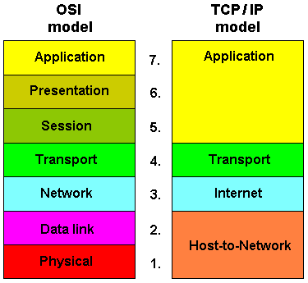

Hubs
A hub is typically the least expensive, least intelligent, and least complicated of the three. Its job is very simple – anything that comes in one port is sent out to the others.
That’s it.
If a message¹ comes in for computer “A”, that message is sent out all the other ports, regardless of which one computer “A” is on:
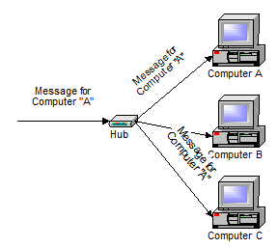
And when computer “A” responds, its response also goes out to every other port on the hub:
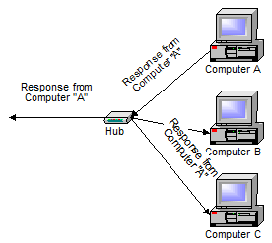
Every computer connected to the hub “sees” everything that every other computer on the hub sees. The computers themselves decide if they are the targeted recipient of the message and when a message should be paid attention to or not.
The hub itself is blissfully ignorant of the data being transmitted. For years, simple hubs have been quick and easy ways to connect computers in small networks.

Switches
A switch does essentially what a hub does, but more efficiently. By paying attention to the traffic that comes across it, it can “learn” where particular addresses are.
Initially, a switch knows nothing and simply sends on incoming messages to all ports:
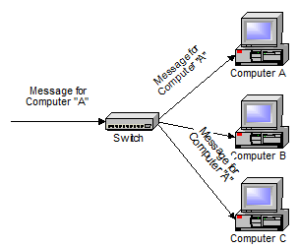
Even accepting that first message, however, the switch has learned something – it knows on which connection the sender of the message is located. Thus, when machine “A” responds to the message, the switches only need to send that message out to the one connection:
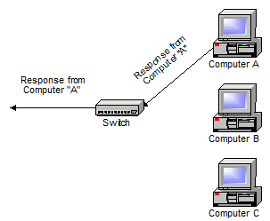
In addition to sending the response through to the originator, the switch has now learned something else – it now knows on which connection machine “A” is located.
That means that subsequent messages destined for machine “A” need only be sent to that one port:
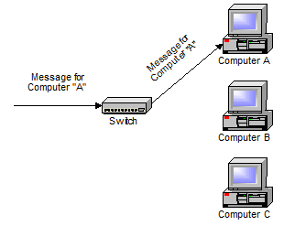
Switches learn the location of the devices that they are connected to almost instantaneously. The net result is that most network traffic only goes where it needs to rather than to every port. On busy networks, this can make the network significantly faster.

Routers
A router is the smartest and most complicated of the bunch. Routers come in all shapes and sizes – from the small, four-port broadband routers that are very popular right now to the large industrial strength devices that drive the internet itself.
A simple way to think of a router is as a computer that can be programmed to understand, possibly manipulate, and route the data that it’s being asked to handle. Many routers today are, in fact, little computers dedicated to the task of routing network traffic.
As far as simple traffic routing is concerned, a router operates exactly as a switch, learning the location of the computers on its connections and routing traffic only to those computers.
Consumer grade routers perform at minimum two additional and important
tasks: DHCP and NAT.
DHCP – Dynamic Host Configuration Protocol – is the way dynamic IP addresses are assigned. A device asks for an IP address to be assigned to it from “upstream” and a DHCP server responds with an IP address assignment. A router connected to your ISP-provided internet connection will typically ask your ISP’s server for an IP address; this will be your IP address on the internet. Your local computers, on the other hand, will ask the router for an IP address and these addresses are local to your network.
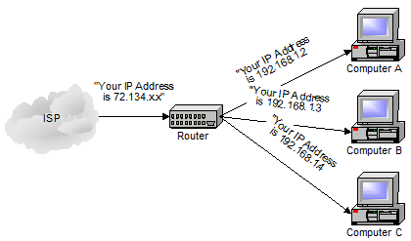
NAT – Network Address Translation – is the way that the router translates the IP addresses of packets that cross the internet/local network boundary. When computer “A” sends a packet out, the IP address that it’s “from” is that of computer “A” – 192.168.1.2 in the example above. When the router passes that on to the internet, it replaces the local IP address with the internet IP address assigned by the ISP. It also keeps track, so that if a response comes back from somewhere on the internet, the router knows to do the translation in reverse – replace the internet IP address with the local IP address for machine “A” and then send that response packet on to machine “A”.
A side effect of NAT is that machines on the internet cannot initiate communications to local machines – they can only respond to communications initiated by those local machines.
The net effect is that the router then also acts as a firewall:
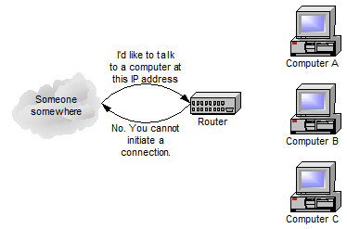
What that means is that malware that might spread by trying to independently connect to your computer over the network cannot.
All routers include some kind of user interface for configuring how the router will treat traffic. The really large routers include the equivalent of a full-blown programming language to describe how they should operate as well as the ability to communicate with other routers to describe or determine the best way to get network traffic from point A to point B.

The Difference Between IPv6 and IPv4 IP Addresses
An IP address is binary numbers but can be stored as text for human readers. For example, a 32-bit numeric address (IPv4) is written in decimal as four numbers separated by periods. Each number can be zero to 255. For example, 1.160.10.240 could be an IP address.
IPv6 addresses are 128-bit IP address written in hexadecimal and separated by colons. An example IPv6 address could be written like this: 3ffe:1900:4545:3:200:f8ff:fe21:67cf (see "What does an IPv6 address look like?")

What is IPv4 -- Internet Protocol Version 4?
IPv4 (Internet Protocol Version 4) is the fourth revision of the Internet Protocol (IP) used to to identify devices on anetwork through an addressing system. The Internet Protocol is designed for use in interconnected systems of packet-switched computer communication networks (see RFC:791).
IPv4 is the most widely deployed Internet protocol used to connect devices to the Internet. IPv4 uses a 32-bitaddress scheme allowing for a total of 2^32 addresses (just over 4 billion addresses). With the growth of theInternet it is expected that the number of unused IPv4 addresses will eventually run out because every device -- including computers, smartphones and game consoles -- that connects to the Internet requires an address.
A new Internet addressing system Internet Protocol version 6 (IPv6) is being deployed to fulfill the need for more Internet addresses.

What is IPv6 -- Internet Protocol Version 6?
IPv6 (Internet Protocol Version 6) is also called IPng (Internet Protocol next generation) and it is the newest version of the Internet Protocol (IP) reviewed in the IETF standards committees to replace the current version of IPv4 (Internet Protocol Version 4).
IPv6 is the successor to Internet Protocol Version 4 (IPv4). It was designed as an evolutionary upgrade to the Internet Protocol and will, in fact, coexist with the older IPv4 for some time. IPv6 is designed to allow the Internet to grow steadily, both in terms of the number of hosts connected and the total amount of data traffic transmitted.
IPv6 is often referred to as the "next generation" Internet standard and has been under development now since the mid-1990s. IPv6 was born out of concern that the demand for IP addresses would exceed the available supply.
While increasing the pool of addresses is one of the most often-talked about benefit of IPv6, there are other important technological changes in IPv6 that will improve the IP protocol:
- No more NAT (Network Address Translation)
- Auto-configuration
- No more private address collisions
- Better multicast routing
- Simpler header format
- Simplified, more efficient routing
- True quality of service (QoS), also called "flow labeling"
- Built-in authentication and privacy support
- Flexible options and extensions
- Easier administration (say good-bye to DHCP)
Unicode:
A standard for representing characters as integers. Unlike ASCII, which uses 7 bits for each character, Unicode uses 16 bits, which means that it can represent more than 65,000 unique characters. This is a bit of overkill for English and Western-Europeanlanguages, but it is necessary for some other languages, such as Greek, Chinese and Japanese. Many analysts believe that as thesoftware industry becomes increasingly global, Unicode will eventually supplant ASCII as the standard character coding format.
Popular Unicode Used software in Bangladesh:
Avro is a Unicode software. Popular Unicode Fonts Are: SolaimanLipi, Vrinda, nikosh Etc. please download the Avro soft and use it a bit to feel confident.

What is Black box test and white box test.
Black-box testing is a method of software testing that examines the functionality of an application without peering into its internal structures or workings. This method of test can be applied to virtually every level of software testing: unit, integration, system and acceptance.

White-box testing (also known as clear box testing, glass box testing, transparent box testing, and structural testing) is a method of testing software that tests internal structures or workings of an application, as opposed to its functionality (i.e. black-box testing).
Criteria | Black Box Testing | White Box Testing
Definition | Black Box Testing is a software testing method in which the internal structure/ design/ implementation of the item being tested is NOT known to the tester | White Box Testing is a software testing method in which the internal structure/ design/ implementation of the item being tested is known to the tester.
Levels Applicable To | Mainly applicable to higher levels of testing:Acceptance Testing  System Testing | Mainly applicable to lower levels of testing:Unit Testing  Integration Testing
Responsibility | Generally, independent Software Testers | Generally, Software Developers
Programming Knowledge | Not Required | Required
Implementation Knowledge | Not Required | Required
Basis for Test Cases | Requirement Specifications | Detail Design
Cloud Computing:
In the simplest terms, cloud computing means storing and accessing data and programs over the Internet instead of your computer's hard drive. The cloud is just a metaphor for the Internet. It goes back to the days of flowcharts and presentations that would represent the gigantic server-farm infrastructure of the Internet as nothing but a puffy, white cumulonimbus cloud, accepting connections and doling out information as it floats.
What cloud computing is not about is your hard drive. When you store data on--or run programs from the hard drive, that's called local storage and computing. Everything you need is physically close to you, which means accessing your data is fast and easy (for that one computer, or others on the local network). Working off your hard drive is how the computer industry functioned for decades and some argue it's still superior to cloud computing, for reasons I'll explain shortly.
The cloud is also not about having a dedicated hardware server in residence. Storing data on a home or office network does not count as utilizing the cloud.
For it to be considered "cloud computing," you need to access your data or your programs over the Internet, or at the very least, have that data synchronized with other information over the Net. In a big business, you may know all there is to know about what's on the other side of the connection; as an individual user, you may never have any idea what kind of massive data-processing is happening on the other end. The end result is the same: with an online connection, cloud computing can be done anywhere, anytime.
Consumer vs. Business
Let's be clear here. We're talking about cloud computing as it impacts individual consumers—those of us who sit back at home or in small-to-medium offices and use the Internet on a regular basis.
There is an entirely different "cloud" when it comes to business. Some businesses choose to implement Software-as-a-Service (SaaS), where the business subscribes to an application it accesses over the Internet. (Think Salesforce.com.) There's also Platform-as-a-Service (PaaS), where a business can create its own custom applications for use by all in the company. And don't forget the mighty Infrastructure-as-a-Service (IaaS), where players like Amazon, Google, and Rackspace provide a backbone that can be "rented out" by other companies. (Think Netflix providing services to you because it's a customer of the cloud-services at Amazon.)
Of course, cloud computing is big business: McKinsey & Company, a global management consulting firm, claims that 80 percent of the large companies in North America that it's surveyed are either looking at using cloud services—or already have. The market is on its way to generating $100 billion a year.
For a great look at more examples of business services in the cloud, read our 20 Top Cloud Services for Small Business.

Diff betn Hacking and phishing
Phishing is when you are led to a fake website, such as a fake bank website where someone can get your details when you log on.
Hacking is when someone uses software or some other special device that allows someone to enter a users computer without them knowing (or knowing) to get information.
Phishing and hacking are related in that they both are ways of obtaining info whether it being volountary (input on a website) or involountary (where someone has taken over your system to get what they want)

What are malware, viruses, Spyware, and cookies, and what differentiates them ?
"Malware" is short for malicious software and used as a single term to refer to virus, spy ware, worm etc. Malware is designed to cause damage to a stand alone computer or a networked pc. So wherever a malware term is used it means a program which is designed to damage your computer it may be a virus, worm or Trojan.
Worms:-
Worms are malicious programs that make copies of themselves again and again on the local drive, network shares, etc. The only purpose of the worm is to reproduce itself again and again. It doesn’t harm any data/file on the computer. Unlike a virus, it does not need to attach itself to an existing program. Worms spread by exploiting vulnerabilities in operating systems
Examples of worm are: - W32.SillyFDC.BBY
Packed.Generic.236
W32.Troresba
Due to its replication nature it takes a lot of space in the hard drive and consumes more cpu uses which in turn makes the pc too slow also consumes more network bandwidth.
Virus:-
Virus is a program written to enter to your computer and damage/alter your files/data. A virus might corrupt or delete data on your computer. Viruses can also replicate themselves. A computer Virus is more dangerous than a computer worm as it makes changes or deletes your files while worms only replicates itself with out making changes to your files/data.
Examples of virus are: - W32.Sfc!mod
ABAP.Rivpas.A
Accept.3773
Viruses can enter to your computer as an attachment of images, greeting, or audio / video files. Viruses also enters through downloads on the Internet. They can be hidden in a free/trial softwares or other files that you download.
So before you download anything from internet be sure about it first. Almost all viruses are attached to an executable file, which means the virus may exist on your computer but it actually cannot infect your computer unless you run or open the malicious program. It is important to note that a virus cannot be spread without a human action, such as running an infected program to keep it going.
*Virus is a program to cause damage to computer.
*Trojan is a program which is used to gain access to a computer by installing a program on infected PC to open some backdoor. [Trojans are also known as Backdoors].
*Worm is a program which infects the computers which are connected by some network. Worms slow down the network.
* Spywares are the program which are used to monitor/Log the activity performed on a computer. These are used to spy on some one either for legal or illegal perpose. Example: Keylogger applications.
* Adwares are the programs which delivers ads to your computer (generally in POP-UP's form). They consume your network.
*Malwares are the program with malicious intention. It can be damaging your computer, spying on you or any other malicious task
Digital Signature:

A digital signature (not to be confused with a digital certificate) is a mathematical technique used to validate the authenticity and integrity of a message, software, or digital document.
The digital equivalent of a handwritten signature or stamped seal, but offering far more inherent security, a digital signature is intended to solve the problem of tampering and impersonation in digital communications. Digital signatures can provide the added assurances of evidence to origin, identity and status of an electronic document, transaction or message, as well as acknowledging informed consent by the signer.
In many countries, including the United States, digital signatures have the same legal significance as the more traditional forms of signed documents. The United States Government Printing Office publishes electronic versions of the budget, public and private laws, and congressional bills with digital signatures.

How digital signatures work
Digital signatures are based on public key cryptography, also known asasymmetric cryptography. Using a public key algorithm such as RSA, one can generate two keys that are mathematically linked: one private and one public. To create a digital signature, signing software (such as an email program) creates a one-way hash of the electronic data to be signed. Theprivate key is then used to encrypt the hash. The encrypted hash -- along with other information, such as the hashing algorithm -- is the digital signature. The reason for encrypting the hash instead of the entire message or document is that a hash function can convert an arbitrary input into a fixed length value, which is usually much shorter. This saves time since hashing is much faster than signing.

The value of the hash is unique to the hashed data. Any change in the data, even changing or deleting a single character, results in a different value. This attribute enables others to validate the integrity of the data by using the signer's public key to decrypt the hash. If the decrypted hash matches a second computed hash of the same data, it proves that the data hasn't changed since it was signed. If the two hashes don't match, the data has either been tampered with in some way (integrity) or the signature was created with a private key that doesn't correspond to the public key presented by the signer (authentication).
A digital signature can be used with any kind of message -- whether it is encrypted or not -- simply so the receiver can be sure of the sender's identity and that the message arrived intact. Digital signatures make it difficult for the signer to deny having signed something (non-repudiation) -- assuming their private key has not been compromised -- as the digital signature is unique to both the document and the signer, and it binds them together. A digital certificate, an electronic document that contains the digital signature of the certificate-issuing authority, binds together a public key with an identity and can be used to verify a public key belongs to a particular person or entity.
Most modern email programs support the use of digital signatures and digital certificates, making it easy to sign any outgoing emails and validate digitally signed incoming messages. Digital signatures are also used extensively to provide proof of authenticity, data integrity and non-repudiation of communications and transactions conducted over the Internet.

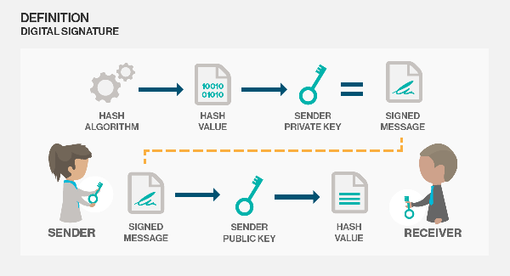

Digital Certificate:
In cryptography, a public key certificate (also known as a digital certificate or identitycertificate) is an electronic document used to prove ownership of a public key.

A digital certificate is an electronic "passport" that allows a person, computer or organization to exchange information securely over the Internet using the public key infrastructure (PKI). A digital certificate may also be referred to as a public key certificate.
Just like a passport, a digital certificate provides identifying information, is forgery resistant and can be verified because it was issued by an official, trusted agency. The certificate contains the name of the certificate holder, a serial number, expiration dates, a copy of the certificate holder's public key (used for encrypting messages and digital signatures) and the digital signature of the certificate-issuing authority (CA) so that a recipient can verify that the certificate is real.
To provide evidence that a certificate is genuine and valid, it is digitally signed by a root certificate belonging to a trusted certificate authority. Operating systems and browsers maintain lists of trusted CA root certificates so they can easily verify certificates that the CAs have issued and signed. When PKI is deployed internally, digital certificates can be self-signed.

VIRUS: Virtual Information Resource Under Seize

Quadratic Equations


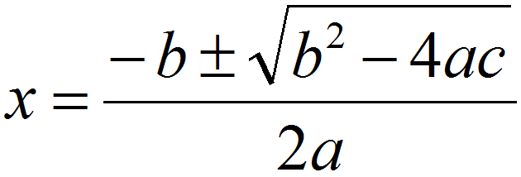

1. C program to calculate roots of a quadratic equation
2. Quadratic equation in c language

#include<stdio.h>
#include<math.h>

int main(){
float a,b,c;
float d,root1,root2;
printf("Enter a, b and c of quadratic equation: ");
scanf("%f%f%f",&a,&b,&c);
d = b * b - 4 * a * c;
if(d < 0){
printf("Roots are complex number.\n");

printf("Roots of quadratic equation are: ");
printf("%.3f%+.3fi",-b/(2*a),sqrt(-d)/(2*a));
printf(", %.3f%+.3fi",-b/(2*a),-sqrt(-d)/(2*a));

return 0;
}
else if(d==0){
printf("Both roots are equal.\n");

root1 = -b /(2* a);
printf("Root of quadratic equation is: %.3f ",root1);

return 0;
}
else{
printf("Roots are real numbers.\n");

root1 = ( -b + sqrt(d)) / (2* a);
root2 = ( -b - sqrt(d)) / (2* a);
printf("Roots of quadratic equation are: %.3f , %.3f",root1,root2);
}

return 0;
}

Sample output:
Enter a, b and c of quadratic equation: 2 4 1
Roots are real numbers.
Roots of quadratic equation are: -0.293, -1.707

What is SDLC? Software Development Life Cycle Defined
SDLC stands for Software Development Life Cycle. A Software Development Life Cycle is essentially a series of steps, or phases, that provide a model for the development and lifecycle management of an application or piece of software. The methodology within the SDLC process can vary across industries and organizations, but standards such as ISO/IEC 12207 represent processes that establish a lifecycle for software, and provide a mode for the development, acquisition, and configuration of software systems.
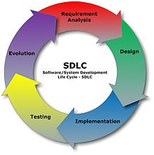
What is System :
A system is a collection of elements or components that are organized for a common purpose. The word sometimes describes the organization or plan itself (and is similar in meaning to method, as in "I have my own little system") and sometimes describes the parts in the system (as in "computer system").
A computer system consists of hardware components that have been carefully chosen so that they work well together and software components or programs that run in the computer.
The main software component is itself an operating system that manages and provides services to other programs that can be run in the computer.
A filing system is a group of files organized with a plan (for example, alphabetical by customer).
All of nature and the universe can be said to be a system. We've coined a word, ecosystem, for the systems on Earth that affect life systems.
The term can be very useful because so many things can be described as systems. It can also be very unuseful when a more specific term is needed.

What is e-Government?
The term e-Government is understood differently across the world. E-Government or Electronic Government is the delivery of more convenient, customer-oriented and cost effective public services and sharing of information through electronic media. Specifically, e-Government harnesses information and communication technologies (such as Wide Area Networks, the Internet, and mobile computing) to transform relations with citizens, businesses, and other arms of government.

What is the difference between e-Government and e-Governance?
E-Government is the transformation of internal and external public sector relationships, through Information and Communications Technology (ICT) in order to optimize government service delivery and citizen participation. Digital society is a society or community that is well advanced in the adoption and integration of digital technology into daily life at home, work and play.
E-Governance is the development, deployment and enforcement of the policies, laws and regulations necessary to support the functioning of a Knowledge Society as well as of e-Government.
What are the objectives of e-Governance?
The strategic objective of e-Governance is to support and simplify governance for government, citizens and businesses. The use of ICT can connect all three parties and support processes and activities. Other objectives are to make government administration more transparent, speedy and accountable, while addressing the society’s needs and expectations through efficient public services and effective interaction between the people, businesses and government.
What are the benefits of e-Governance?
E-Governance offers many benefits and advantages for the government, corporate sector and society. E-Governance facilitates better delivery of government services to citizens, improved interactions with business and industry, citizen empowerment through access to information, or more efficient government management. It simplifies internal operations and improves performance of government departments while helping all sections of society to avail government services at lower cost with maximum ease of use.
Here are several specific benefits of e-Governance.
By employing online transactions, government processes become more streamlined, efficient and less dependent on human interaction. Also the cost of processing transactions is reduced online, resulting in great savings.
Interconnecting various ministries and government departments electronically to share information helps them provide better governance.
Through one integrated e-Government portal, citizens and businesses can avail of various government services, conduct online transactions, access information and interact with various government bodies without standing in long queues, waiting for office hours or handling lot of paperwork, and thus save time and money.
In short, e-Governance brings about ‘anytime anywhere access to the right person’.
Tell me more about an e-Governance model.
E-Government applications normally evolve through a four-stage process. The four stages are Information, Interaction, Transaction and Transformation. The first stage includes the publication of information on a website for citizens seek knowledge about procedures governing the delivery of different services. The second stage involves interactivity. Clients can download applications for receiving services. The third stage involves electronic delivery of documents. The fourth stage involves electronic delivery of services where more than one department may be involved in processing a service request or service.
Dead Lock:
A deadlock is a situation in which two computer programs sharing the same resource are effectively preventing each other from accessing the resource, resulting in both programs ceasing to function. The earliest computer operating systems ran only one program at a time.
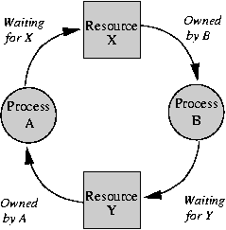

Data Gathering Tools:
As part of needs assessment it is valuable to learn about trends in teaching and learning both at your institutional level and across higher education in general. These trends provide insight into dynamics such as students’ use of technology, trends in pedagogy, and campus priorities.

Usage Data
If you are renovating a new space or designing a completely new space, there might be data already gathered at your space’s organization that will be valuable for helping you make decisions. For example, it can be useful to gather data about (1) computer usage, (2) transactions at a service point, and (3) existing building use (gate counts, head counts, etc.)

Observation
Formal observation of users is an inexpensive method for discovering more about learners’ behaviors and uses of existing spaces.

Interviews
Interviews can provide invaluable insight into the behaviors, attitudes, and preferences of a space’s current or potential users.

Photo Interviews / Photo Diary
The photo interview or photo diary is a qualitative research method in which the researcher gives the interviewee a camera and a list of prompts for taking photos. The images are then used as a catalyst for discussion during the interview. This method can be used to learn about students’ work practices, life experiences as members of a campus community, and their behaviors in and preferences for different learning spaces. Example Photo Interview Prompts – Example prompts used at the NCSU Libraries as part of a photo interviews (photo diary) project focused on learning about their opinions and perspectives on existing spaces and services.

Focus Groups
Focus groups can be used to understand participants’ work habits, types of assignments, gaps in existing spaces and services, and more.
- Overview of gathering data using focus groups
- Focus Groups: Things to Consider
- ARL Learning Space Pre-Programming Tool Kit – Contains a useful overview of conducting focus groups

Surveys
Surveys can provide a breadth of information about your users’ preferences and behaviors pertaining to existing learning spaces and technologies, which can inform decisions for planning a new space.

IP Address:

An Internet Protocol address (IP address) is a numerical label assigned to each device (e.g., computer, printer) participating in a computer network that uses theInternet Protocol for communication.^{[1]} An IP address serves two principal functions: host or network interface identification and location addressing. Its role has been characterized as follows: "A name indicates what we seek. An address indicates where it is. A route indicates how to get there."^{[2]}
The designers of the Internet Protocol defined an IP address as a 32-bit number^{[1]} and this system, known as Internet Protocol Version 4 (IPv4), is still in use today. However, because of the growth of the Internet and the predicted depletion of available addresses, a new version of IP (IPv6), using 128 bits for the address, was developed in 1995.^{[3]} IPv6 was standardized as RFC 2460 in 1998,^{[4]} and its deployment has been ongoing since the mid-2000s.
IP addresses are usually written and displayed in human-readable notations, such as 172.16.254.1 (IPv4), and 2001:db8:0:1234:0:567:8:1 (IPv6).
The Internet Assigned Numbers Authority (IANA) manages the IP address space allocations globally and delegates five regional Internet registries (RIRs) to allocate IP address blocks to local Internet registries (Internet service providers) and other entities.
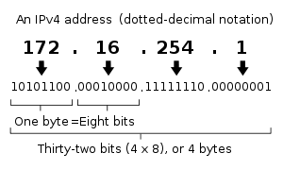
IP V6:
The rapid exhaustion of IPv4 address space, despite conservation techniques, prompted the Internet Engineering Task Force (IETF) to explore new technologies to expand the addressing capability in the Internet. The permanent solution was deemed to be a redesign of the Internet Protocol itself. This next generation of the Internet Protocol, intended to replace IPv4 on the Internet, was eventually named Internet Protocol Version 6(IPv6) in 1995.^{[3][4]} The address size was increased from 32 to 128 bits or 16 octets. This, even with a generous assignment of network blocks, is deemed sufficient for the foreseeable future. Mathematically, the new address space provides the potential for a maximum of 2¹²⁸, or about 3.403×10³⁸ addresses.
The primary intent of the new design is not to provide just a sufficient quantity of addresses, but rather to allow an efficient aggregation of subnetwork routing prefixes at routing nodes. As a result, routing table sizes are smaller, and the smallest possible individual allocation is a subnet for 2⁶⁴ hosts, which is the square of the size of the entire IPv4 Internet. At these levels, actual address utilization rates will be small on any IPv6 network segment. The new design also provides the opportunity to separate the addressing infrastructure of a network segment, that is the local administration of the segment's available space, from the addressing prefix used to route external traffic for a network. IPv6 has facilities that automatically change the routing prefix of entire networks, should the global connectivity or the routing policy change, without requiring internal redesign or manual renumbering.
The large number of IPv6 addresses allows large blocks to be assigned for specific purposes and, where appropriate, to be aggregated for efficient routing. With a large address space, there is no need to have complex address conservation methods as used in CIDR.
Many modern desktop and enterprise server operating systems include native support for the IPv6 protocol, but it is not yet widely deployed in other devices, such as home networking routers, voice over IP (VoIP) and multimedia equipment, and network peripherals.
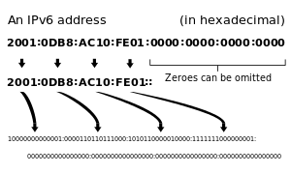
Wi-Fi:
Wi-Fi is the name of a popular wireless networking technology that uses radio waves to provide wireless high-speed Internet andnetwork connections. A common misconception is that the term Wi-Fi is short for "wireless fidelity," however this is not the case. Wi-Fi is simply a trademarked phrase that means IEEE 802.11x.

The Wi-Fi Alliance
The Wi-Fi Alliance, the organization that owns the Wi-Fi registered trademark term specifically defines Wi-Fi as any "wireless local area network (WLAN) products that are based on the Institute of Electrical and Electronics Engineers' (IEEE) 802.11 standards."
Initially, Wi-Fi was used in place of only the 2.4GHz 802.11b standard, however the Wi-Fi Alliance has expanded the generic use of the Wi-Fi term to include any type of network or WLAN product based on any of the 802.11 standards, including 802.11b, 802.11a, dual-band, and so on, in an attempt to stop confusion about wireless LAN interoperability.

Wi-Fi Hotspot:
A hotspot is a physical location that offers Internet access over a wireless local area network (WLAN) through the use of a router connected to a link to an Internet service provider. Hotspots typically use Wi-Fitechnology.

WiMax:
WiMAX (Worldwide Interoperability for Microwave Access) is a wireless communications standard designed to provide 30 to 40 megabit-per-second data rates, with the 2011 update providing up to 1 Gbit/s for fixed stations.
WiMAX is one of the hottest broadband wireless technologies around today. WiMAX systems are expected to deliver broadband access services to residential and enterprise customers in an economical way.
Loosely, WiMax is a standardized wireless version of Ethernet intended primarily as an alternative to wire technologies (such as Cable Modems, DSL and T1/E1 links) to provide broadband access to customer premises.
More strictly, WiMAX is an industry trade organization formed by leading communications, component and equipment companies to promote and certify compatibility and interoperability of broadband wireless access equipment that conforms to the IEEE 802.16 and ETSI HIPERMAN standards.
WiMAX would operate similar to WiFi but at higher speeds over greater distances and for a greater number of users. WiMAX has the ability to provide service even in areas that are difficult for wired infrastructure to reach and the ability to overcome the physical limitations of traditional wired infrastructure.
WiMAX was formed in April 2001, in anticipation of the publication of the original 10-66 GHz IEEE 802.16 specifications. WiMAX is to 802.16 as the WiFi Alliance is to 802.11.
WiMAX is:
- Acronym for Worldwide Interoperability for Microwave Access.
- Based on Wireless MAN technology.
- A wireless technology optimized for the delivery of IP centric services over a wide area.
- A scaleable wireless platform for constructing alternative and complementary broadband networks.
- A certification that denotes interoperability of equipment built to the IEEE 802.16 or compatible standard. The IEEE 802.16 Working Group develops standards that address two types of usage models:
  - A fixed usage model (IEEE 802.16-2004).
  - A portable usage model (IEEE 802.16e).

Questionnaires and Interviews
Questionnaires: a set of printed or written questions with a choice of answers, devised for the purposes of a survey or statistical study.
Interview: a meeting of people face to face, especially for consultation.

Asking questions can provide measurement of many concepts and variables important to transportation research. Transportation practitioners ask questions frequently as part of assessment and evaluation. The important thing to remember when choosing this method is that it must be the most appropriate one to measure the variables as you have defined them. Whether you use the interview or questionnaire method, it must be because your operational definition calls for the subject’s self-report. If it does not, or if there is reason to believe that the person cannot give a valid response then these methods are not appropriate. The major difference between questionnaires and interviews is the presence of an interviewer. In questionnaires, responses are limited to answers to predetermine questions. In interviews, since the interviewer is present with the subject, there is an opportunity to collect nonverbal data as well and to clarify the meaning of questions if the subjects do not understand. The written questionnaire has some advantages. For one thing, it is likely to be less expensive, particularly in terms of the time spent collecting the data. Questionnaires can be given to large numbers of people simultaneously; they can also be sent by mail. Therefore, it is possible to cover wide geographic areas and to question large number of people relatively inexpensively. Another advantage of questionnaires is that subjects are more likely to feel that they can remain anonymous and thus may be more likely to express controversial opinions. This is more difficult in an interview, where the opinion must be given directly to the interviewer. Also, the written question is standard from one subject to the next and is not susceptible to changes in emphasis as can be case in oral questioning. There is always the possibility, however, that the written question will be interpreted differently by different readers, which is one reason for carefully pre-testing questionnaires. Interviews have many advantages, the most significant of which is questioning people who cannot write their responses. This category also includes illiterate subjects or subjects who do not write as frequently as they speak. Oral responses from these individuals will contain much more information than would their written responses. Another advantage of the interview method is that is actually results in a higher response rate than does the questionnaire. Many people who would ignore a questionnaire are willing to talk, with an interviewer who is obviously interested in what they have to say. Another advantage of the interview technique is that you can plan to ask questions at several levels to get the most information from the subject. This approach is unique to the interview. The combination of structured and unstructured questions can provide depth and richness to the data and, at the same time elicit data that are comparable from one subject to the next. When looking for a questionnaire or interview schedule to use in your study or when developing your own tool, you will have to consider the various kinds of questions that you can ask to obtain a range of data, and then decide which method is best suited to your variables. The content of the questions must be considered first, then the amount of structure in the format. Question content or the purpose of the question falls into two basic categories: those aimed at facts and those aimed at perceptions or feelings. Factual questions ask subjects for information about themselves or about even or people about which they know something. Nonfactual questions deal with the subjects’ perception of what happened or their feelings about people, events, or things. They may also deal with the subjects’ reasons for their behavior. In these kinds of questions, you are not interested in whether the subject’s report is accurate but rather in the subject’s perception, which may or may not accurately reflect the facts. The format of interviews and questionnaires, as that of observational methods, can range from very structured to very unstructured, depending on how much is known about the range of possible responses. Criteria for Selecting the Interview or Questionnaire Advantages of the Interview Advantages of the Questionnaire The subject needs be able to read or write This approach is less expensive in terms of time and money The interviewer can observe the responses of the subject Subjects feel a greater sense of anonymity Questions may be clarified if they are misunderstood The format is standard for all subjects and is not dependent on mood of interviewer An-depth data may be obtained on any subject and are not dependent on predetermined questions Large samples, covering large geographic areas, compensate for the expected loss of subjects There is a higher response and retention rate A greater amount of data over a broad range of topics may be collected

SEA-ME-WE 4:
South East Asia–Middle East–Western Europe 4 (SEA-ME-WE 4) is an optical fibresubmarine communications cable system that carries telecommunications betweenSingapore, Malaysia, Thailand, Bangladesh, India, Sri Lanka, Pakistan, United Arab Emirates, Saudi Arabia, Sudan, Egypt, Italy, Tunisia, Algeria and France.^{[1]} It is intended to be a complement to, rather than a replacement for, the SEA-ME-WE 3 cable.
The cable is approximately 18,800 kilometres long, and provides the primary Internet backbone between South East Asia, the Indian subcontinent, the Middle East andEurope.^{[1][2]}

Minister of Roads Division:
Obaidul Quader,
Honorable Minister of Ministry of Road Transport and Bridges

Secretary of Roads Division:
Mr. M. A. N. Siddique,
Secretary, Road Transport and Highways Division
Ministry of Road Transport and Bridges
RHD Network
  Road length by classification
  National Highway | : | 3,812.78 Km
  Regional Highway | : | 4,246.97 Km
  Zila Road | : | 13,242.33 Km
  Total Road Length | : | 21,302.08 Km
  Bridges & Culvert
  Bridges | : | 4507
  Culvert | : | 13751

- Idea about “Mukti Juddho” and osthai sorkar ….. read from BCS Guide books.
- Between: Switch, Router, Hub, Bridge (Which one resides in which network layer)
- What is Database, Relational Database, Relations, Normalization, One2one-many etc, stored procedure, trigger.
- OS for Mobile phone: Simbean.
- Make some Papers of your developed software.
- Publish some Journal (International) and show it to the viva.
- What will be your responsibilities???
- How can you contribute country from your post???
- What is Port? Port KZ ai‡bi n‡q _v‡K?
- PvKzix n‡j Avcwb cÖwZôv‡b wK wK KvR Ki‡eb?
- GKRb wm‡÷g Gbvwj÷/†cÖvMÖvgv‡ii `vwqZ¡vejx wK wK?
- What is Domain? .gov.bd wK ai‡bi †Wv‡gvBb?
- wek¦ †gav m¤ú` w`em KZ ZvwiL?
- What is the different between While & Do While Loop?
- What is OOP (Object-Oriented Programming)?
- the different between Class & Structure? Inheritence, polimorfism, encapsulation.
- GKwU Efficient Search Algorithm Gi bvg e‡jb?
- OSI Reference Model layer ¸‡jv wK wK? TCP/IP Gi mv‡_ Gi cv_©K¨ wK?
- What is the different between Router & Switch?
LAN established Ki‡Z wK wK equipment cÖ‡qvRb?
- GKRb wm‡÷g Gbvwj‡÷i/ asst.prog./ prog wK wK `¶Zv _vKv cÖ‡qvRb?
- Linux: Different types of linux OS, DNS Configure, Proxy Configure, Samba, Gateway Configure, Mail Server Configure, File Server Configure and other basic operation of Linux.
- What is L1,L2,L3 cache memory???
- Read about Bangladesh Sonbidan basic, Impeachments
- What is a computer system
- Diff between multitasking and multi threading
Programming with C/VB:
- Arrange a string in reverse order
- Sort a number array into ascending / descending order
- String reverse program.

What is e-Governance:
Electronic governance or e-governance is the application of information and communication technology (ICT) for deliveringgovernment services, exchange of information communication transactions, integration of various stand-alone systems and services between government-to-customer (G2C), government-to-business (G2B), government-to-government (G2G) as well as back office processes and interactions within the entire government framework.^{[1]} Through e-governance, government services will be made available to citizens in a convenient, efficient and transparent manner. The three main target groups that can be distinguished in governance concepts are government, citizens and businesses/interest groups. In e-governance there are no distinct boundaries.^{[2]}
Generally four basic models are available – government-to-citizen (customer), government-to-employees, government-to-government and government-to-business.^{[2]}
Both the terms are treated to be the same, however, there is some difference between the two. "E-government" is the use of the ICTs in public administration - combined with organizational change and new skills - to improve public services and democratic processes and to strengthen support to public. The problem in this definition to be congruence definition of e-governance is that there is no provision for governance of ICTs. As a matter of fact, the governance of ICTs requires most probably a substantial increase in regulation and policy-making capabilities, with all the expertise and opinion-shaping processes along the various social stakeholders of these concerns. So, the perspective of the e-governance is "the use of the technologies that both help governing and have to be governed".^{[3]} The Public-Private Partnership (PPP) based e-governance projects are hugely successful in India. United Telecoms Limited known as UTL is a major player in India on PPP based e-governance projects . Each project had mammoth state wide area networks in these states.
Many countries are looking forward to for a corruption-free government. E-government is one-way communication protocolwhereas e-governance is two-way communication protocol. The essence of e-governance is to reach the beneficiary and ensure that the services intended to reach the desired individual has been met with. There should be an auto-response to support the essence of e-governance, whereby the Government realizes the efficacy of its governance. E-governance is by the governed, for the governed and of the governed.
Establishing the identity of the end beneficiary is a challenge in all citizen-centric services. Statistical information published by governments and world bodies does not always reveal the facts. The best form of e-governance cuts down on unwanted interference of too many layers while delivering governmental services. It depends on good infrastructural setup with the support of local processes and parameters for governments to reach their citizens or end beneficiaries.Budget for planning, development and growth can be derived from well laid out e-governance systems

WHAT IS GOOD GOVERNANCE?
Good governance is about the processes for making and implementing decisions. It’s not about making ‘correct’ decisions, but about the best possible process for making those decisions.
Good decision-making processes, and therefore good governance, share several characteristics. All have a positive effect on various aspects of local government including consultation policies and practices, meeting procedures, service quality protocols, councillor and officer conduct, role clarification and good working relationships.

WHAT ARE THE MAIN CHARACTERISTICS OF GOOD GOVERNANCE?

Good governance is accountable
Accountability is a fundamental requirement of good governance. Local government has an obligation to report, explain and be answerable for the consequences of decisions it has made on behalf of the community it represents.

Good governance is transparent
People should be able to follow and understand the decision-making process. This means that they will be able to clearly see how and why a decision was made – what information, advice and consultation council considered, and which legislative requirements (when relevant) council followed.

Good governance follows the rule of law
This means that decisions are consistent with relevant legislation or common law and are within the powers of council. In the case of Victorian local government, relevant legislation includes the Local Government Act 1989 and other legislation such as the Public Health and Wellbeing Act 2008, and the Equal Opportunity Act 2010.

Good governance is responsive
Local government should always try to serve the needs of the entire community while balancing competing interests in a timely, appropriate and responsive manner.

Good governance is equitable and inclusive
A community’s wellbeing results from all of its members feeling their interests have been considered by council in the decision-making process. This means that all groups, particularly the most vulnerable, should have opportunities to participate in the process.

Good governance is effective and efficient
Local government should implement decisions and follow processes that make the best use of the available people, resources and time to ensure the best possible results for their community.

Good governance is participatory
Anyone affected by or interested in a decision should have the opportunity to participate in the process for making that decision. This can happen in several ways – community members may be provided with information, asked for their opinion, given the opportunity to make recommendations or, in some cases, be part of the actual decision-making process.
It is important to remember that under the Local Government Act 1989 the council is required to either make decisions or delegate the decision-making power to officers or Special Committees. For more information see How decisions are made.
- See more at: http://www.goodgovernance.org.au/about-good-governance/what-is-good-governance/#sthash.dF8NapgN.dpuf
Cache Memory:
Typically there are now 3 layers of cache on modern CPU cores:
- L1 cache is very small and very tightly bound to the actual processing units of the CPU, it can typically fulfil data requests within 3 CPU clock ticks. L1 cache tends to be around 4-32KB depending on CPU architecture and is split between instruction and data caches.
- L2 cache is generally larger but a bit slower and is generally tied to a CPU core. Recent processors tend to have 512KB of cache per core and this cache has no distinction between instruction and data caches, it is a unified cache. I believe the response time for in-cache data is typically under 20 CPU "ticks"
- L3 cache tends to be shared by all the cores present on the CPU and is much larger and slower again, but it is still a lot faster than going to main memory. L3 cache tends to be of the order of 4-8MB these days.

Cache memory levels explained
Cache memory is fast and expensive. Traditionally, it is categorized as "levels" that describe its closeness and accessibility to the microprocessor:
- Level 1 (L1) cache is extremely fast but relatively small, and is usually embedded in the processor chip (CPU).
- Level 2 (L2) cache is often more capacious than L1; it may be located on the CPU or on a separate chip or coprocessor with a high-speed alternative system bus interconnecting the cache to the CPU, so as not to be slowed by traffic on the main system bus.
- Level 3 (L3) cache is typically specialized memory that works to improve the performance of L1 and L2. It can be significantly slower than L1 or L2, but is usually double the speed of RAM. In the case of multicore processors, each core may have its own dedicated L1 and L2 cache, but share a common L3 cache. When an instruction is referenced in the L3 cache, it is typically elevated to a higher tier cache.

Multiprograming
Running more then one program with in an application to perform a certain task.
Example : In MS WORD, Writing in document and sending Email
Multitasking
Running more then one application to perform a certain task.
Example: listening Song, playing game, work in ms word, excel and other applications simultaneously
Multiprocessing
Running more then one instruction through a processor.
Example When create a file then computer takes Time and date default.
shareimprove this answer
Multithreading Multithreading extends the idea of multitasking into applications, so you can subdivide specific operations within a single application into individual threads.

